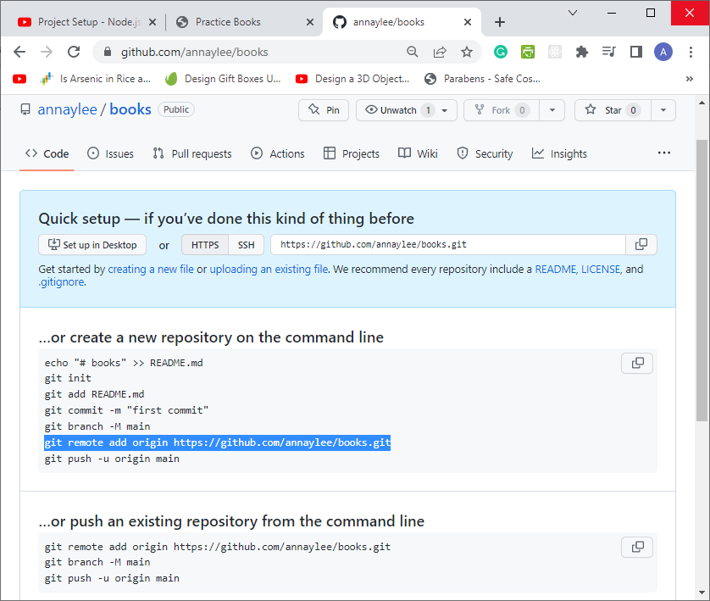
Create a GitHub repo for books:

MongoDB Atlas:

Log In: anna_y_lee@hotmail.com Iacaa4mda$ ( I am creating an account 4 mongoDB Atlas $ )

General Steps:
Create Cluster: Choose a Provider and Region ( AWS – US Oregon ) to create a cloud hosted database.
After the cluster is created, click “Connect” → “Connect to Your Application” to see the below URL:

mongodb+srv://annaylee:<password>@cluster0.rlacf0i.mongodb.net/?retryWrites=true&w=majority
Replace <password> with Iacaa4mda$

